TITLE OF YOUR EXTENDED ABSTRACT (TNR, Bold 14pt centered)

Author, A¹, Author, B², and Author, C³ (TNR 12pt centered)

¹Institution 1(TNR 12pt centered)
²Institution 2 (TNR 12pt centered)
³Institution 3 (TNR 12pt centered)
E-mail (corresponding author)

- INTRODUCTION (headlines: TNR Bold, 12pt)
In conjunction with the 2nd IC- RDAMSE 2026 theme, papers of relevant topics within the conference theme are invited for oral/poster presentations. Authors are requested to submit an extended abstract not exceeding two (2) pages in English.
The extended abstract must include the title, author(s) introduction, material and methods, results and discussion, conclusion and references. The manuscript should be prepared on an A4-sized paper with 25 mm margins on all sides and typed with single spacing using size 12 Times New Roman font. All illustrations must be prepared inside of the main text. Selected papers will be published in the reputed Scopus indexed journal.

- MATERIALS AND METHODS (headlines: TNR, Bold, 12pt)

The methodology must be clearly stated and described in sufficient detail or with sufficient references.

- RESULTS AND DISCUSSION (headlines: TNR Bold, 12pt)
The findings and arguments of the work should be explicitly described and illustrated. Supporting figures, tables and images of the work.
All the tables, images and figures should be centered. Figures and images should be numbered and figure headers should be placed under the figure or image; as for the tables, they should also be numbered and the table header should be placed at the top. References (if any) of the tables, figures and images should be presented right under the tables, figures and images in the form of author surname and publication date.
Equations should be centered and numbered consecutively, as in Eq. [1]. An alternative method is given in Eq. [2] for long sets of equations where only one referencing equation number is wanted.
(1 line spacing here)

 | 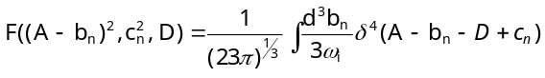 | [1]

Tables and figures
Tables and figures should appear in one column of a page and be numbered consecutively. Figures and texts may appear on the same page, and a centered caption should appear directly beneath the figure. It is preferable that figures be mounted in portrait style and figure captions are no longer than two lines. On figures showing graphs, both axes must be clearly labeled (including units if applicable).
Tables should be designed to have a uniform style throughout the paper, following the style shown in Table 1. Table captions should be in 10pt “Time News Roman” bold, centered, and the texts in Table should be set in 9pt “Time News Roman” font.

Table 1. Caption heading for a table should be placed at the top of the table and within table width.
(Use “time news roman” font, size 10pt, No spacing after table title)
 | A | B | C | D
A | Aa | Ab | Ac | Ad
B | Ba | Bb | Bc | Bd
C | Ca | Cb | Cc | Cd
D | Da | Db | Dc | Dd
E | Ea | Eb | Ec | Ed

Authors are advised to prepare their figures in either black and white or color. Please prepare the figures in high resolution (300 dpi) for half-tone illustrations or images. Pictures must be sharp enough otherwise they will be rejected. Figures must be originals, computer-generated or drafted, and placed within the text area where they are discussed. Figure 1 shows one example. Figure captions should be in 10pt “Time News Roman” font, bold, centered. When applicable, the texts in graphs, illustrations or images should be set in 8pt “Time News Roman” font.
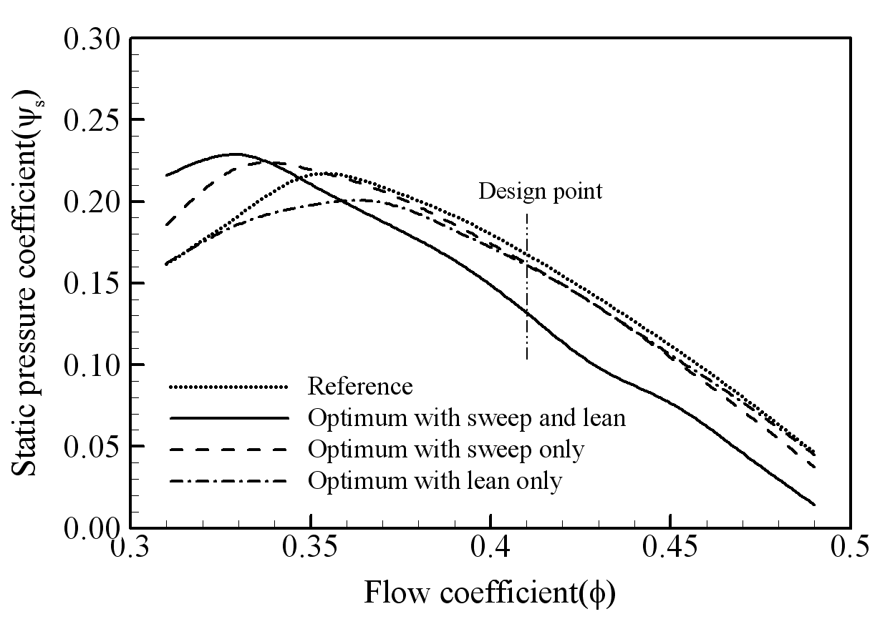
Figure 1. The caption heading for a figure should be placed below the figure and within figure/illustration width. (Use “Time News Roman” font, size 10pt, no spacing between title and figure)

- CONCLUSION (headlines: TNR Bold, 12pt)
Conclusions should include (1) the principles and generalisations inferred from the results, (2) any exceptions to, or problems with these principles and generalisations, (3) theoretical and/or practical implications of the work, and (5) conclusions drawn and recommendations.

- ACKNOWLEDGMENT (headlines: TNR Bold, 12pt)
The authors would like to express appreciation for the support of the sponsors [Project Number = XXXXXXX].

- REFERENCES (headlines: TNR Bold, 12pt)
1. Author, F.: Article title. Journal 2(5), 99–110 (2016).
2. Author, F., Author, S.: Title of a proceedings paper. In: Editor, F., Editor, S. (eds.) CONFERENCE 2016, LNCS, vol. 9999, pp. 1–13. Springer, Heidelberg (2016).
3. Author, F., Author, S., Author, T.: Book title. 2nd edn. Publisher, Location (1999).
4. Author, F.: Contribution title. In: 9th International Proceedings on Proceedings, pp. 1–2. Publisher, Location (2010).
5. LNCS Homepage, http://www.springer.com/lncs, last accessed 2016/11/21.

